q1- hacker earth 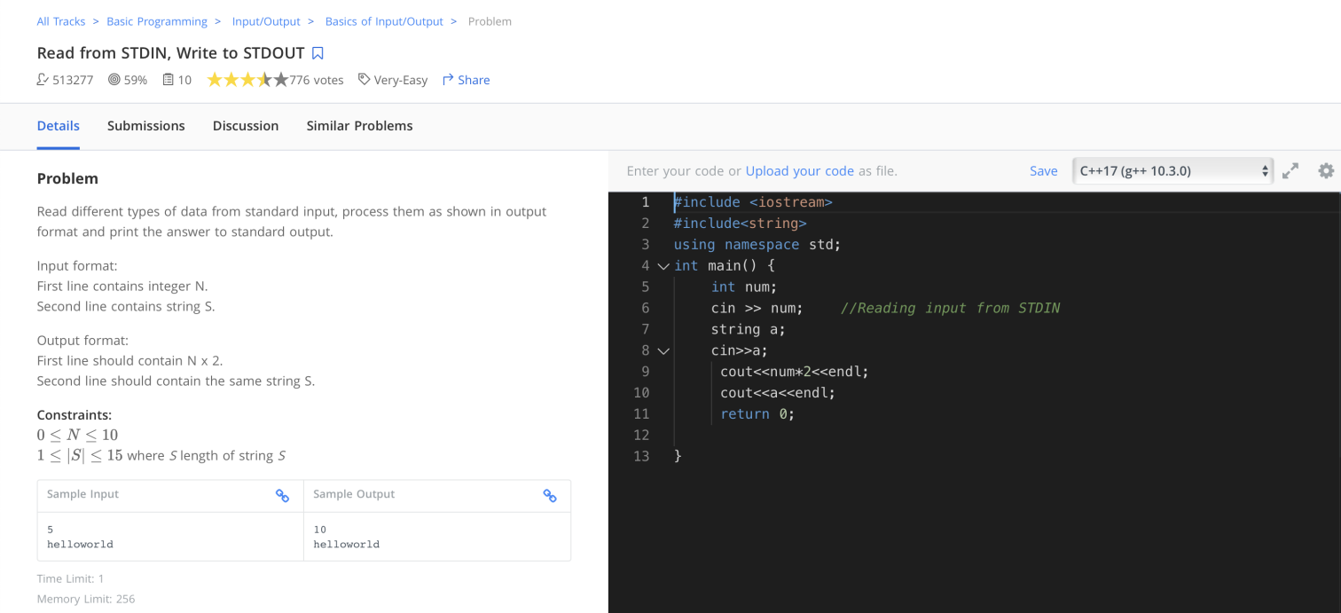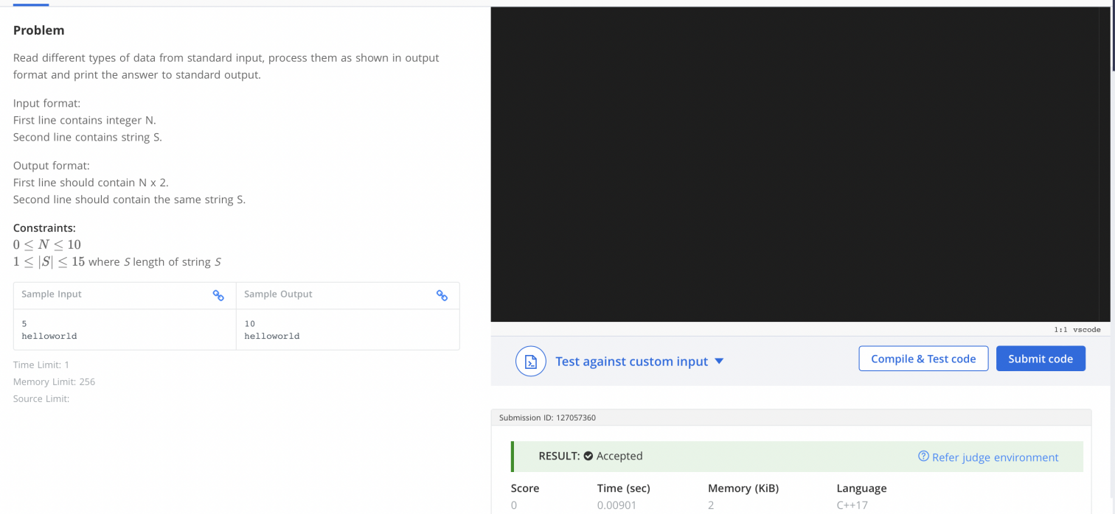
q2- ZOOS problem
#include <stdio.h>
#include <string.h>

int main() {
char word[100000];
scanf("%s", word);

int znum = 0, onum = 0;

for (int i = 0; word[i] != '\0'; i++) {
if (word[i] == 'z')
znum++;
else if (word[i] == 'o')
onum++;
}

if (onum == 2 * znum)
printf("Yes");
else
printf("No");

return 0;
}

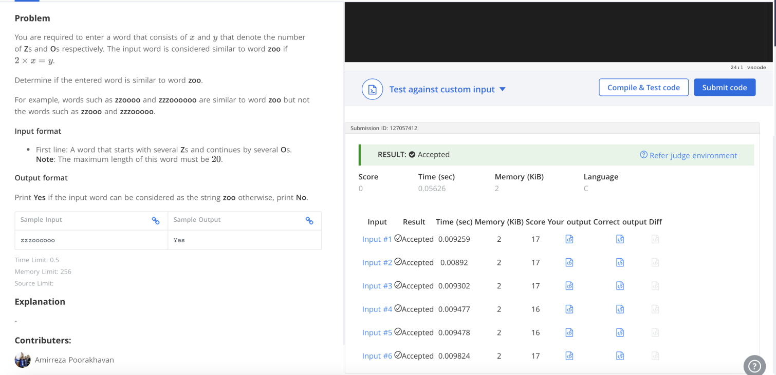
q3- favourite singer
#include <stdio.h>
#include <stdlib.h>

typedef long long ll;

// Comparator for qsort
int cmp(const void *a, const void *b) {
ll x = *(ll*)a;
ll y = *(ll*)b;
if (x > y) return 1;
if (x < y) return -1;
return 0;
}

int main() {
ll n;
scanf("%lld", &n);

ll *arr = (ll*)malloc(n * sizeof(ll));

for (ll i = 0; i < n; i++)
scanf("%lld", &arr[i]);

// Sort the array so identical singers group together
qsort(arr, n, sizeof(ll), cmp);

ll maxFreq = 1;
ll currFreq = 1;
ll favCount = 0;

for (ll i = 1; i < n; i++) {
if (arr[i] == arr[i - 1]) {
currFreq++;
} else {
if (currFreq > maxFreq) {
maxFreq = currFreq;
favCount = 1;
} else if (currFreq == maxFreq) {
favCount++;
}
currFreq = 1;
}
}

// Check the last block
if (currFreq > maxFreq) {
maxFreq = currFreq;
favCount = 1;
} else if (currFreq == maxFreq) {
favCount++;
}

printf("%lld\n", favCount);

free(arr);
return 0;
}
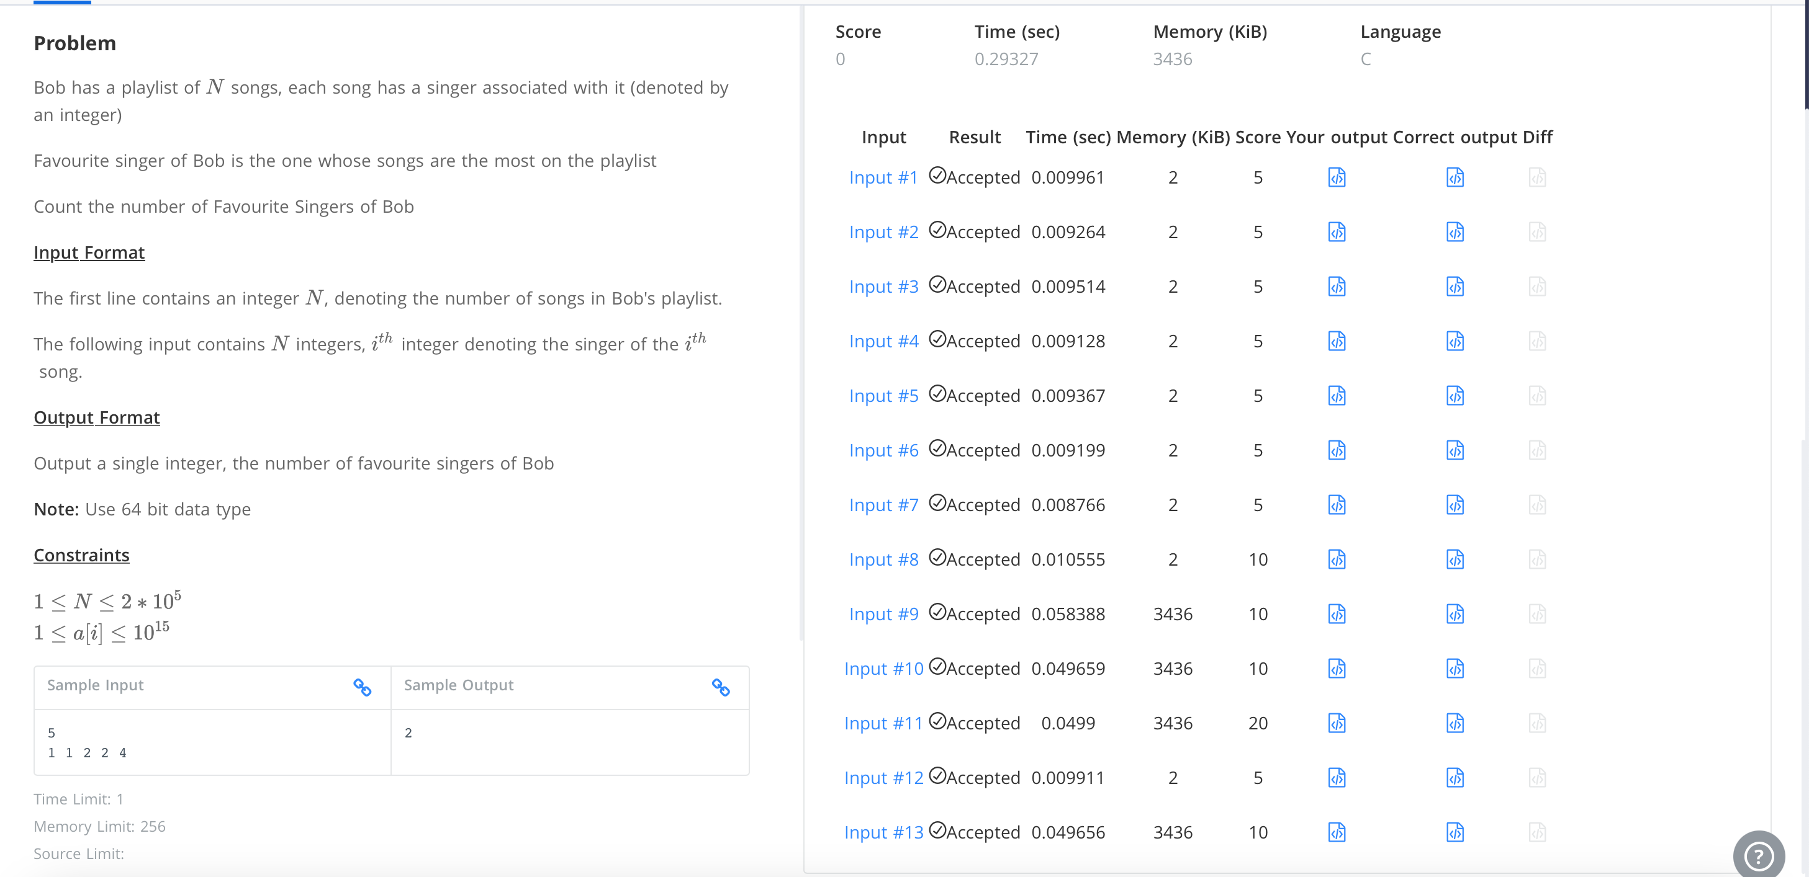
q4- toggle string
#include <stdio.h>

int main() {
char s[100000];
scanf("%s", s);

for (int i = 0; s[i] != '\0'; i++) {

if (s[i] >= 'a' && s[i] <= 'z') {
s[i] = s[i] - 'a' + 'A';
}

else if (s[i] >= 'A' && s[i] <= 'Z') {
s[i] = s[i] - 'A' + 'a';
}
}

printf("%s", s);

return 0;
}

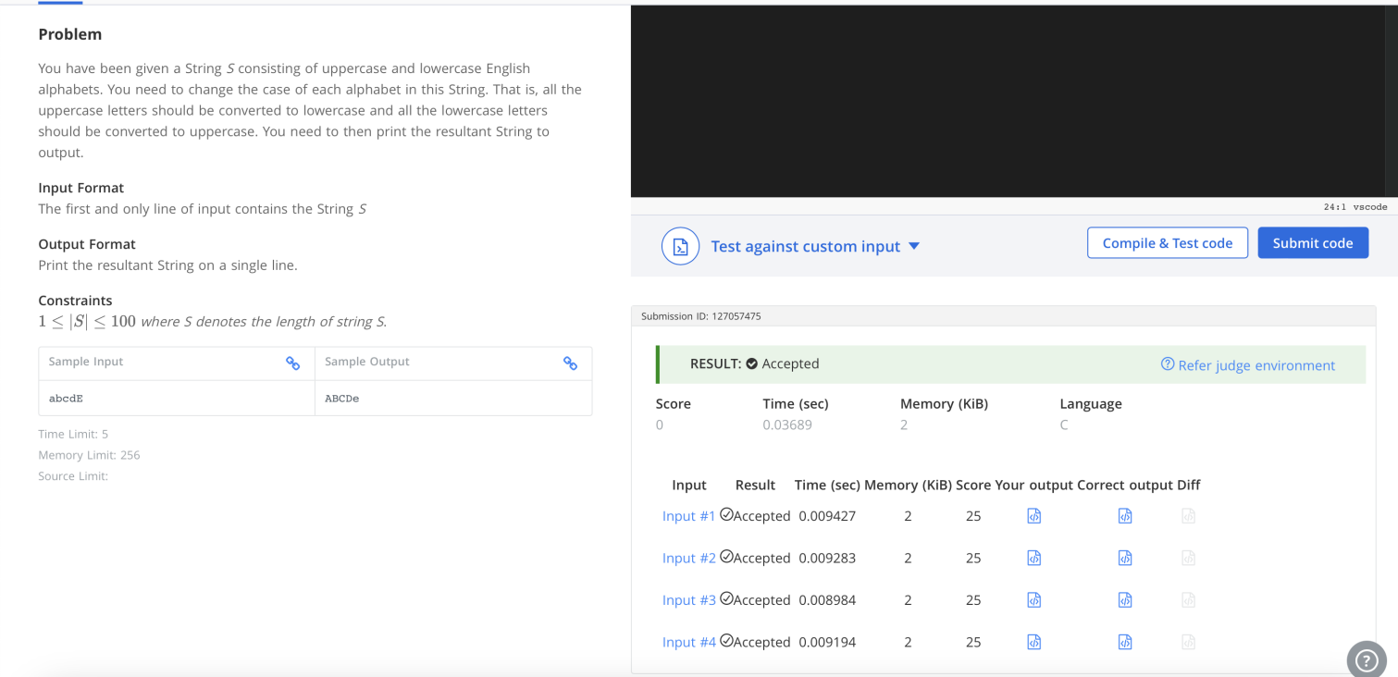
q5- palindromic string
#include <iostream>
#include<string>
using namespace std;
int main() {
string s;
cin>>s;
for(int i=0;i<s.length();i++){
if(s[i]!=s[s.length()-i-1])
{

cout<<"NO";
return 0;
}
}
cout<<"YES";
return 0;
}
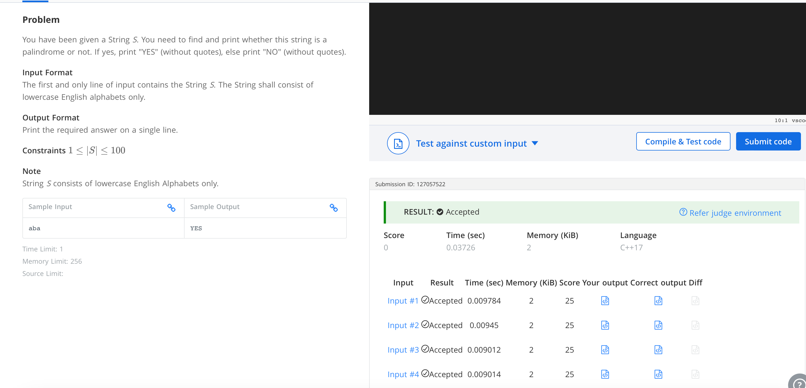
q7- count divisors
#include <stdio.h>

int main(){
int l,r,k;
scanf("%d %d %d",&l,&r,&k);
int count=0;
for (int i = l; i <= r; i++) {
if (i % k == 0) {
count++;
}
}
printf("%d",count);
return 0;
}

